Министерство образования и молодежной политики Свердловской области



ГАПОУ СО «Екатеринбургский колледж транспортного строительства»

Отчёт по программе «**Pacman в Python**»

Выполнил: Юнусов Руслан Александрович

Группа: ПР-32

Преподаватель: Шевцова Вера Дмитриевна

2024

**Задание:** Разработать игру Pacman в Python

**Входные и выходные данные**

**Direction – класс кнопок передвижения  
game_renderer – класс рендеринга игры  
GameObject – класс родитель всех объектов  
Ghost – класс призраков  
Coockie – класс печенек  
PacmanGameController – класс логики игры  
Pathfinder – класс координат  
Hero – класс главного героя  
MovbleObject – класс передвижения**

**Листинг программы (если есть)**

**Main.py**def translate_screen_to_maze(in_coords, in_size=32):

    return int(in_coords[0] / in_size), int(in_coords[1] / in_size)

def translate_maze_to_screen(in_coords, in_size=32):

    return in_coords[0] * in_size, in_coords[1] * in_size

if __name__ == "__main__":

    unified_size = 32

    pacman_game = PacmanGameController()

    size = pacman_game.size

    game_renderer = GameRenderer(size[0] * unified_size, size[1] * unified_size)

    for y, row in enumerate(pacman_game.numpy_maze):

        for x, column in enumerate(row):

            if column == 0:

                game_renderer.add_wall(Wall(game_renderer, x, y, unified_size))

    for cookie_space in pacman_game.cookie_spaces:

        translated = translate_maze_to_screen(cookie_space)

        cookie = Cookie(game_renderer, translated[0] + unified_size / 2, translated[1] + unified_size / 2)

        game_renderer.add_cookie(cookie)

    for i, ghost_spawn in enumerate(pacman_game.ghost_spawns):

        translated = translate_maze_to_screen(ghost_spawn)

        ghost = Ghost(game_renderer, translated[0], translated[1], unified_size, pacman_game,

                      pacman_game.ghost_colors[i % 4])

        game_renderer.add_game_object(ghost)

    pacman = Hero(game_renderer, unified_size, unified_size, unified_size)

    game_renderer.add_hero(pacman)

    game_renderer.tick(120)

**PacmanGameController**

class PacmanGameController:

    def __init__(self):

        self.ascii_maze = [

            "XXXXXXXXXXXXXXXXXXXXXXXXXXXX",

            "XP           XX            X",

            "X XXXX XXXXX XX XXXXX XXXX X",

            "X XXXX XXXXX XX XXXXX XXXX X",

            "X XXXX XXXXX XX XXXXX XXXX X",

            "X                          X",

            "X XXXX XX XXXXXXXX XX XXXX X",

            "X XXXX XX XXXXXXXX XX XXXX X",

            "X      XX    XX    XX      X",

            "XXXXXX XXXXX XX XXXXX XXXXXX",

            "XXXXXX XXXXX XX XXXXX XXXXXX",

            "XXXXXX XX          XX XXXXXX",

            "XXXXXX XX XXXXXXXX XX XXXXXX",

            "XXXXXX XX X   G  X XX XXXXXX",

            "          X G    X          ",

            "XXXXXX XX X   G  X XX XXXXXX",

            "XXXXXX XX XXXXXXXX XX XXXXXX",

            "XXXXXX XX          XX XXXXXX",

            "XXXXXX XX XXXXXXXX XX XXXXXX",

            "XXXXXX XX XXXXXXXX XX XXXXXX",

            "X            XX            X",

            "X XXXX XXXXX XX XXXXX XXXX X",

            "X XXXX XXXXX XX XXXXX XXXX X",

            "X   XX       G        XX   X",

            "XXX XX XX XXXXXXXX XX XX XXX",

            "XXX XX XX XXXXXXXX XX XX XXX",

            "X      XX    XX    XX      X",

            "X XXXXXXXXXX XX XXXXXXXXXX X",

            "X XXXXXXXXXX XX XXXXXXXXXX X",

            "X                          X",

            "XXXXXXXXXXXXXXXXXXXXXXXXXXXX",

        ]

        self.numpy_maze = []

        self.cookie_spaces = []

        self.reachable_spaces = []

        self.ghost_spawns = []

        self.ghost_colors = [

            (255, 184, 255),

            (255, 0, 20),

            (0, 255, 255),

            (255, 184, 82)

        ]

        self.size = (0, 0)

        self.convert_maze_to_numpy()

        self.p = Pathfinder(self.numpy_maze)

    def request_new_random_path(self, in_ghost: Ghost):

        random_space = random.choice(self.reachable_spaces)

        current_maze_coord = translate_screen_to_maze(in_ghost.get_position())

        path = self.p.get_path(current_maze_coord[1], current_maze_coord[0], random_space[1],

                               random_space[0])

        test_path = [translate_maze_to_screen(item) for item in path]

        in_ghost.set_new_path(test_path)

    def convert_maze_to_numpy(self):

        for x, row in enumerate(self.ascii_maze):

            self.size = (len(row), x + 1)

            binary_row = []

            for y, column in enumerate(row):

                if column == "G":

                    self.ghost_spawns.append((y, x))

                if column == "X":

                    binary_row.append(0)

                else:

                    binary_row.append(1)

                    self.cookie_spaces.append((y, x))

                    self.reachable_spaces.append((y, x))

            self.numpy_maze.append(binary_row)

**Pathfinder.py**

class Pathfinder:

    def __init__(self, in_arr):

        cost = np.array(in_arr, dtype=np.bool_).tolist()

        self.pf = tcod.path.AStar(cost=cost, diagonal=0)

    def get_path(self, from_x, from_y, to_x, to_y) -> object:

        res = self.pf.get_path(from_x, from_y, to_x, to_y)

        return [(sub[1], sub[0]) for sub in res]

**Cookie.py**

class Cookie(GameObject):

    def __init__(self, in_surface, x, y):

        super().__init__(in_surface, x, y, 4, (255, 255, 0), True)

**Ghost.py**

class Ghost(MovableObject):

    def __init__(self, in_surface, x, y, in_size: int, in_game_controller, in_color=(255, 0, 0)):

        super().__init__(in_surface, x, y, in_size, in_color, False)

        self.game_controller = in_game_controller

    def reached_target(self):

        if (self.x, self.y) == self.next_target:

            self.next_target = self.get_next_location()

        self.current_direction = self.calculate_direction_to_next_target()

    def set_new_path(self, in_path):

        for item in in_path:

            self.location_queue.append(item)

        self.next_target = self.get_next_location()

    def calculate_direction_to_next_target(self) -> Direction:

        if self.next_target is None:

            self.game_controller.request_new_random_path(self)

            return Direction.NONE

        diff_x = self.next_target[0] - self.x

        diff_y = self.next_target[1] - self.y

        if diff_x == 0:

            return Direction.DOWN if diff_y > 0 else Direction.UP

        if diff_y == 0:

            return Direction.LEFT if diff_x < 0 else Direction.RIGHT

        self.game_controller.request_new_random_path(self)

        return Direction.NONE

    def automatic_move(self, in_direction: Direction):

        if in_direction == Direction.UP:

            self.set_position(self.x, self.y - 1)

        elif in_direction == Direction.DOWN:

            self.set_position(self.x, self.y + 1)

        elif in_direction == Direction.LEFT:

            self.set_position(self.x - 1, self.y)

        elif in_direction == Direction.RIGHT:

            self.set_position(self.x + 1, self.y)

**Hero.py**

class Hero(MovableObject):

    def __init__(self, in_surface, x, y, in_size: int):

        super().__init__(in_surface, x, y, in_size, (255, 255, 0), False)

        self.last_non_colliding_position = (0, 0)

    def tick(self):

        # TELEPORT

        if self.x < 0:

            self.x = self._renderer._width

        if self.x > self._renderer._width:

            self.x = 0

        self.last_non_colliding_position = self.get_position()

        if self.check_collision_in_direction(self.direction_buffer)[0]:

            self.automatic_move(self.current_direction)

        else:

            self.automatic_move(self.direction_buffer)

            self.current_direction = self.direction_buffer

        if self.collides_with_wall((self.x, self.y)):

            self.set_position(self.last_non_colliding_position[0], self.last_non_colliding_position[1])

        self.handle_cookie_pickup()

    def automatic_move(self, in_direction: Direction):

        collision_result = self.check_collision_in_direction(in_direction)

        desired_position_collides = collision_result[0]

        if not desired_position_collides:

            self.last_working_direction = self.current_direction

            desired_position = collision_result[1]

            self.set_position(desired_position[0], desired_position[1])

        else:

            self.current_direction = self.last_working_direction

    def handle_cookie_pickup(self):

        collision_rect = pygame.Rect(self.x, self.y, self._size, self._size)

        cookies = self._renderer.get_cookies()

        game_objects = self._renderer.get_game_objects()

        for cookie in cookies:

            collides = collision_rect.colliderect(cookie.get_shape())

            if collides and cookie in game_objects:

                game_objects.remove(cookie)

    def draw(self):

        half_size = self._size / 2

        pygame.draw.circle(self._surface, self._color, (self.x + half_size, self.y + half_size), half_size)

**MovableObject.py**

class MovableObject(GameObject):

    def __init__(self, in_surface, x, y, in_size: int, in_color=(255, 0, 0), is_circle: bool = False):

        super().__init__(in_surface, x, y, in_size, in_color, is_circle)

        self.current_direction = Direction.NONE

        self.direction_buffer = Direction.NONE

        self.last_working_direction = Direction.NONE

        self.location_queue = []

        self.next_target = None

    def get_next_location(self):

        return None if len(self.location_queue) == 0 else self.location_queue.pop(0)

    def set_direction(self, in_direction):

        self.current_direction = in_direction

        self.direction_buffer = in_direction

    def collides_with_wall(self, in_position):

        collision_rect = pygame.Rect(in_position[0], in_position[1], self._size, self._size)

        collides = False

        walls = self._renderer.get_walls()

        for wall in walls:

            collides = collision_rect.colliderect(wall.get_shape())

            if collides: break

        return collides

    def check_collision_in_direction(self, in_direction: Direction):

        desired_position = (0, 0)

        if in_direction == Direction.NONE: return False, desired_position

        if in_direction == Direction.UP:

            desired_position = (self.x, self.y - 1)

        elif in_direction == Direction.DOWN:

            desired_position = (self.x, self.y + 1)

        elif in_direction == Direction.LEFT:

            desired_position = (self.x - 1, self.y)

        elif in_direction == Direction.RIGHT:

            desired_position = (self.x + 1, self.y)

        return self.collides_with_wall(desired_position), desired_position

    def automatic_move(self, in_direction: Direction):

        pass

    def tick(self):

        self.reached_target()

        self.automatic_move(self.current_direction)

    def reached_target(self):

        pass

**GameRenderer.py**

class GameRenderer:

    def __init__(self, in_width: int, in_height: int):

        pygame.init()

        self._width = in_width

        self._height = in_height

        self._screen = pygame.display.set_mode((in_width, in_height))

        pygame.display.set_caption('Pacman')

        self._clock = pygame.time.Clock()

        self._done = False

        self._game_objects = []

        self._walls = []

        self._cookies = []

        self._hero: Hero = None

    def tick(self, in_fps: int):

        black = (0, 0, 0)

        while not self._done:

            for game_object in self._game_objects:

                game_object.tick()

                game_object.draw()

            pygame.display.flip()

            self._clock.tick(in_fps)

            self._screen.fill(black)

            self._handle_events()

        print("Game over")

    def add_game_object(self, obj: GameObject):

        self._game_objects.append(obj)

    def add_cookie(self, obj: GameObject):

        self._game_objects.append(obj)

        self._cookies.append(obj)

    def add_wall(self, obj: Wall):

        self.add_game_object(obj)

        self._walls.append(obj)

    def get_walls(self):

        return self._walls

    def get_cookies(self):

        return self._cookies

    def get_game_objects(self):

        return self._game_objects

    def add_hero(self, in_hero):

        self.add_game_object(in_hero)

        self._hero = in_hero

    def _handle_events(self):

        for event in pygame.event.get():

            if event.type == pygame.QUIT:

                self._done = True

        pressed = pygame.key.get_pressed()

        if pressed[pygame.K_UP]:

            self._hero.set_direction(Direction.UP)

        elif pressed[pygame.K_LEFT]:

            self._hero.set_direction(Direction.LEFT)

        elif pressed[pygame.K_DOWN]:

            self._hero.set_direction(Direction.DOWN)

        elif pressed[pygame.K_RIGHT]:

            self._hero.set_direction(Direction.RIGHT)

**wall.py**

class Wall(GameObject):

    def __init__(self, in_surface, x, y, in_size: int, in_color=(0, 0, 255)):

        super().__init__(in_surface, x * in_size, y * in_size, in_size, in_color)

**GameObject.py**

class GameObject:

    def __init__(self, in_surface, x, y,

                 in_size: int, in_color=(255, 0, 0),

                 is_circle: bool = False):

        self._size = in_size

        self._renderer: GameRenderer = in_surface

        self._surface = in_surface._screen

        self.y = y

        self.x = x

        self._color = in_color

        self._circle = is_circle

        self._shape = pygame.Rect(self.x, self.y, in_size, in_size)

    def draw(self):

        if self._circle:

            pygame.draw.circle(self._surface,

                               self._color,

                               (self.x, self.y),

                               self._size)

        else:

            rect_object = pygame.Rect(self.x, self.y, self._size, self._size)

            pygame.draw.rect(self._surface,

                             self._color,

                             rect_object,

                             border_radius=4)

    def tick(self):

        pass

    def get_shape(self):

        return self._shape

    def set_position(self, in_x, in_y):

        self.x = in_x

        self.y = in_y

    def get_position(self):

        return (self.x, self.y)

**Скрин-шоты**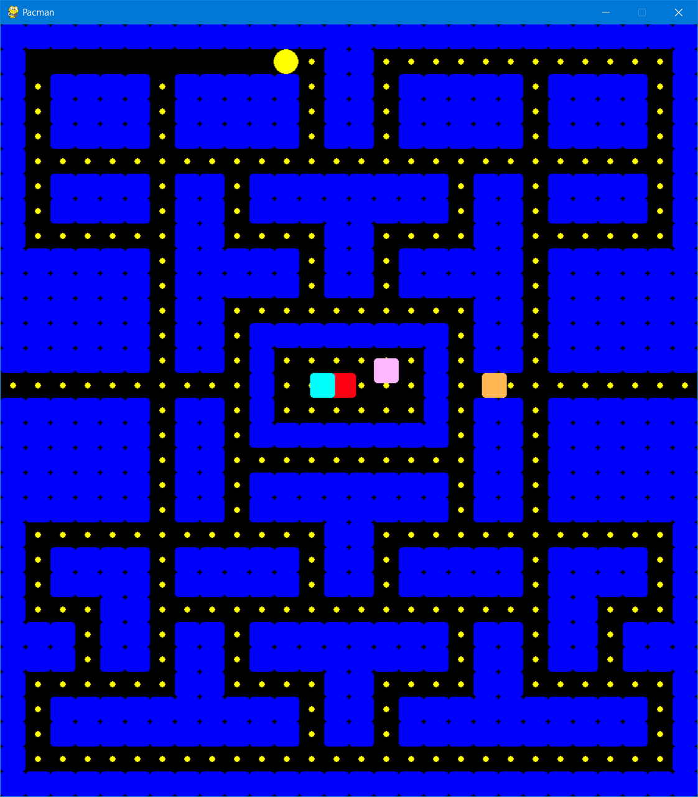

**Вывод**

Я укрепил знания по языку программирования Python, и изучил несколько полезных для меня библиотек.